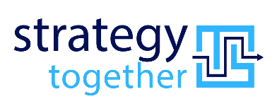

**Industry: Financial Services**

Client: Regional insurance company

Team: Kit Jackson, Warwick Clews, Alice Gustavsson, Kym Hamer

**What Was Needed**

The Insurance Corporation of Barbados Ltd is a traditional market leader in Barbados’ insurance industry, with 170 people.

In 2018, a new CEO was recruited to transform this underperforming general insurer, position it for regional growth and attract new investors.

CEO Geoff Scott engaged Strategy Together to support their journey of developing the capability to deliver on the vision and realise the benefits promised.

2018-2022

**What Happened**

Financial performance 50% better than the best year in ICBL’s 40-year history

Attracted new investors and talent into the business

Positioned ICBL for continued growth in the region with greater brand recognition

Gained understanding, ownership and engagement in making the strategy happen, aligning the organisation and creating the conditions for the whole organisation to think and act strategically

The conventional, avoidant and oppositional culture shifted to become constructive, adaptive to change and high-achieving

Established a new leadership model where everyone was able to contribute as a leader, taking individual responsibility for collective outcomes



*“Kit helped me quickly assess the validity of the company’s strategic ambitions and the organizational capability to execute them using the strategy map methodology. However, it became abundantly clear that Kit had a broad experience, deep expertise and an engaging approach that was to prove invaluable over the four and a half years that we partnered on the transformation of this conventional, underperforming market leader into a profitable, future-fit and attractive business.”* ***Geoff Scott, CEO, ICBL 2018-22***

**What We Did**

Clearly articulated the strategy and developed the execution framework to align and prioritise decisions, activities and initiatives. Established strategy management governance.

Implemented an organisation restructure, operational performance improvement and transition to a hybrid model.

Built strategic leadership capability with Executive Leadership Team and Emerging Leaders.

Engaged all staff in transforming the culture, living the values and aligning behaviours to enhance personal and collective effectiveness and enable the strategic journey.